**RAILWAY MANAGEMENT SYSTEM**

**Data Structures And Algorithms**

**Project Report**

1. **ABSTRACT**

It’s really difficult for the train passengers these days specifically the train travelling passengers to find that one train which is the perfect for them to reach their destination, someone has a problem with the route, some with cost while some people are having problems with the duration of the journey. It happens to cause the railway system is not organised in India, it has many problems in its structure. It’s the real need that someone makes some specific and result worthy changes in the Indian Railway system.

What we aim to achieve is to build a shortest route finder in terms of Distance, Cost and Duration as well. A program through which the user-end i.e. the passengers can easily find the ideal train for their ideal destination by all means. The program will show the passenger all the choices he has in terms of distance, cost and duration. A program using which the reservation is made easy and convenient for the passengers. Also if there is any problem the user can easily do the cancellation and book another train which he finds is more convenient.

This program will also help the Railway Department to handle the big data of the passengers and will make it easy for the railway department to show the most optimal train for one place to another, so they can even charge more those trains and make a reasonable profit.

**2.) INTRODUCTION**

In our documented research we have proposed a program with its system design, through which the railway travellers can easily book the trains which are best for their journey, in this program we will be using Stack and Queue data structures to hold the data. The algorithm which we will be using is the DIJIKSTRA’S ALGORITHM, which gives the shortest path possible between two places.

Since passengers are going to use this so program, so we will also be using the File Handling to store the data and details of the passenger.

What we aim to achieve is to build a shortest route finder in terms of Distance, Cost and Duration as well. A program through which the user-end i.e. the passengers can easily find the ideal train for their ideal destination by all means. The program will show the passenger all the choices he has in terms of distance, cost and duration. A program using which the reservation is made easy and convenient for the passengers.

1. **LITERATURE SURVEY**

**Dijkstra's algorithm-**is an algorithm for finding the shortest paths between nodes in a graph, which may represent, for example, road networks. It was conceived by computer scientist Edsger W. Dijkstra in 1956 and published three years later.The algorithm exists in many variants; Dijkstra's original variant found the shortest path between two nodes, but a more common variant fixes a single node as the "source" node and finds shortest paths from the source to all other nodes in the graph, producing a shortest path tree.

For a given source node in the graph, the algorithm finds the shortest path between that node and every other. It can also be used for finding the shortest paths from a single node to a single destination node by stopping the algorithm once the shortest path to the destination node has been determined.

**File Handling-**A **file** represents a sequence of bytes on the disk where a group of related data is stored. File is created for permanent storage of data. It is a ready made structure.

In C language, we use a structure **pointer of file type** to declare a file.

A file represents a sequence of bytes, regardless of it being a text file or a binary file. C programming language provides access on high level functions as well as low level (OS level) calls to handle file on your storage devices. This chapter will take you through the important calls for file management.

1. **Proposed Method/System**
2. **By DISTANCE**



**ii) By COST**



1. **Implementation**
2. **Results and Discussions**

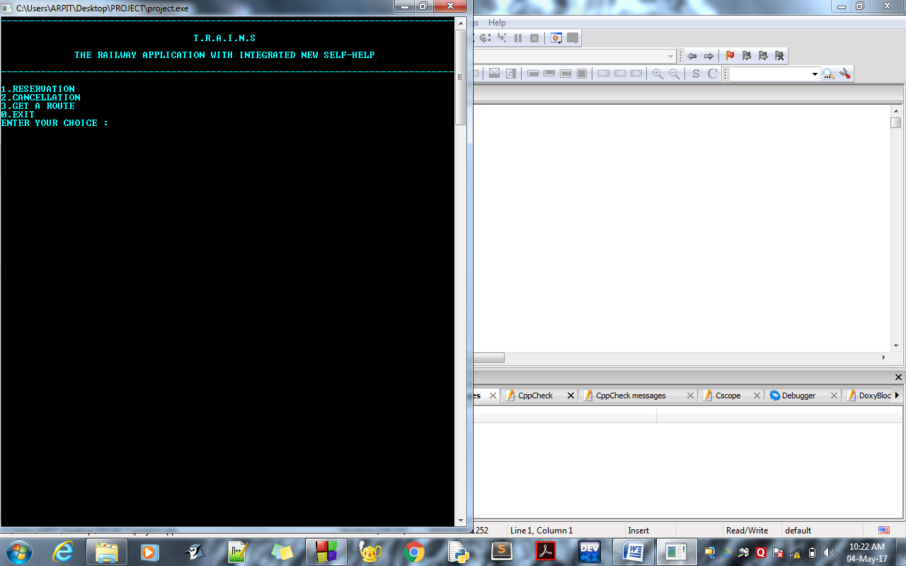

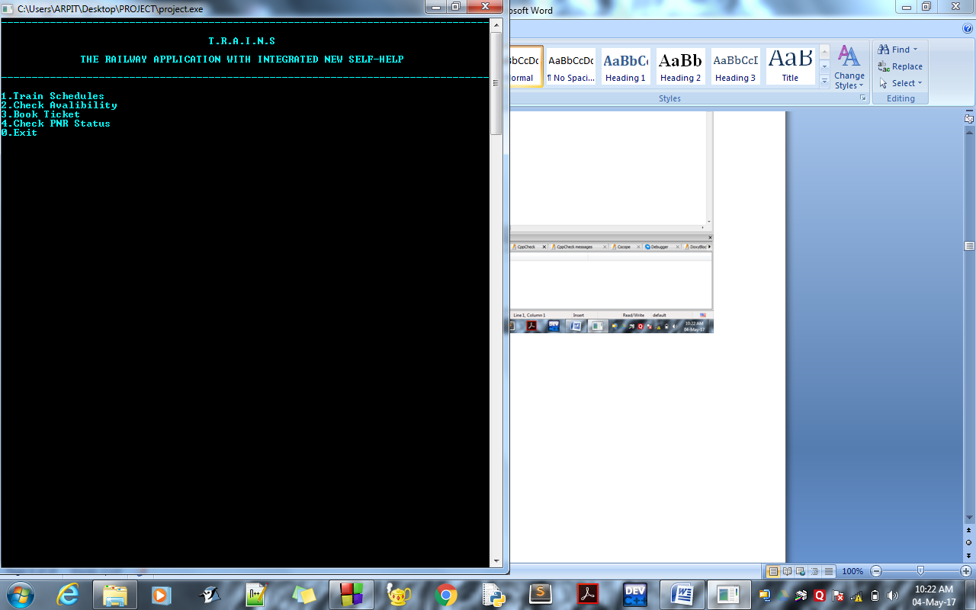

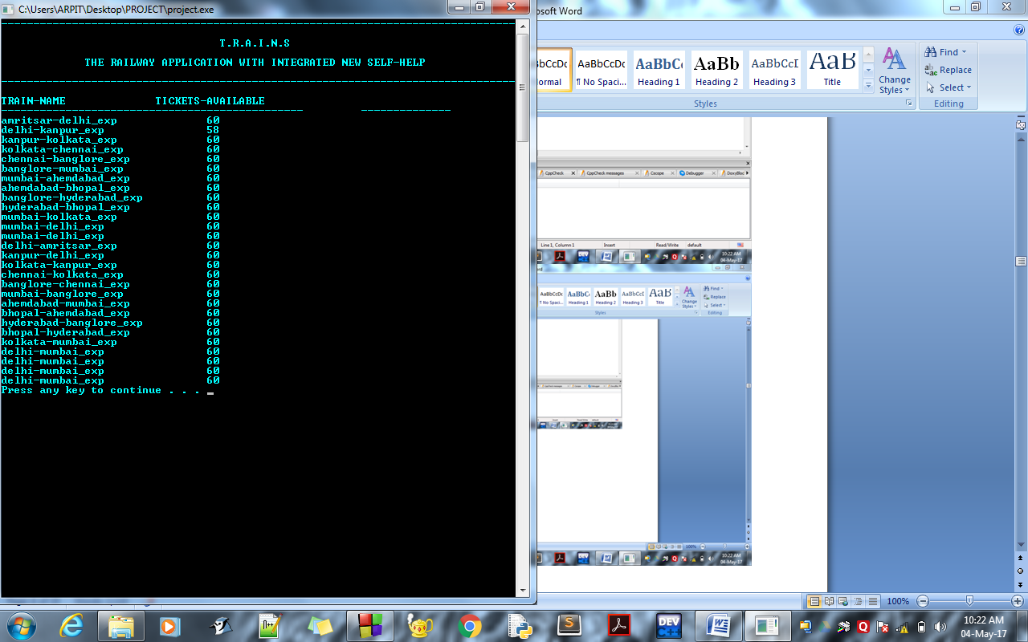

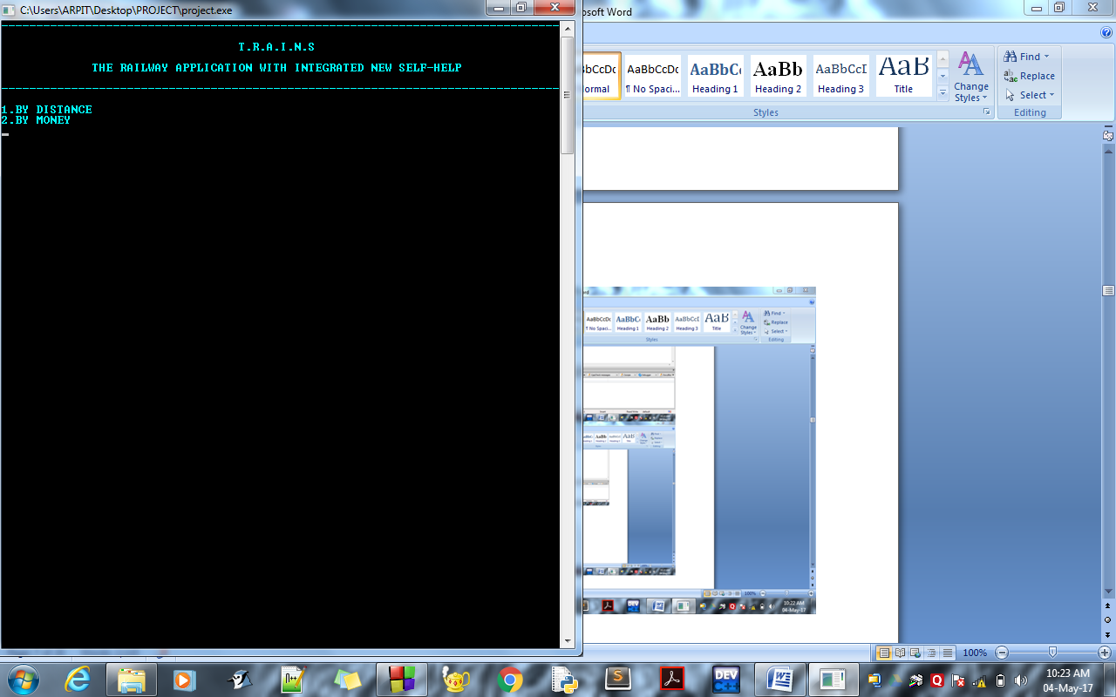

1. **Conclusion**

WE ARE SUCCESSFUL IN COMPLETING OUR PROGRAMME BY DJIKSTRA AND FILE HANDLING .

OUR PROGRAMME IS RUNNING GOOD .

IN THIS PROJECT WE ARE ABLE TO BOOK A TICKET, CHECK AVAILIBILITY FO TICKETS, CANCEL A TICKET AND FIND THE SHORTEST PATH BASED ON THE DISTANCE AND MONEY.

1. **References**

[**http://www.studytonight.com/c/file-input-output.php**](http://www.studytonight.com/c/file-input-output.php)

[**https://www.tutorialspoint.com/cprogramming/c_file_io.htm**](https://www.tutorialspoint.com/cprogramming/c_file_io.htm)

[**http://www.sanfoundry.com/c-programming-examples-file-handling/**](http://www.sanfoundry.com/c-programming-examples-file-handling/)